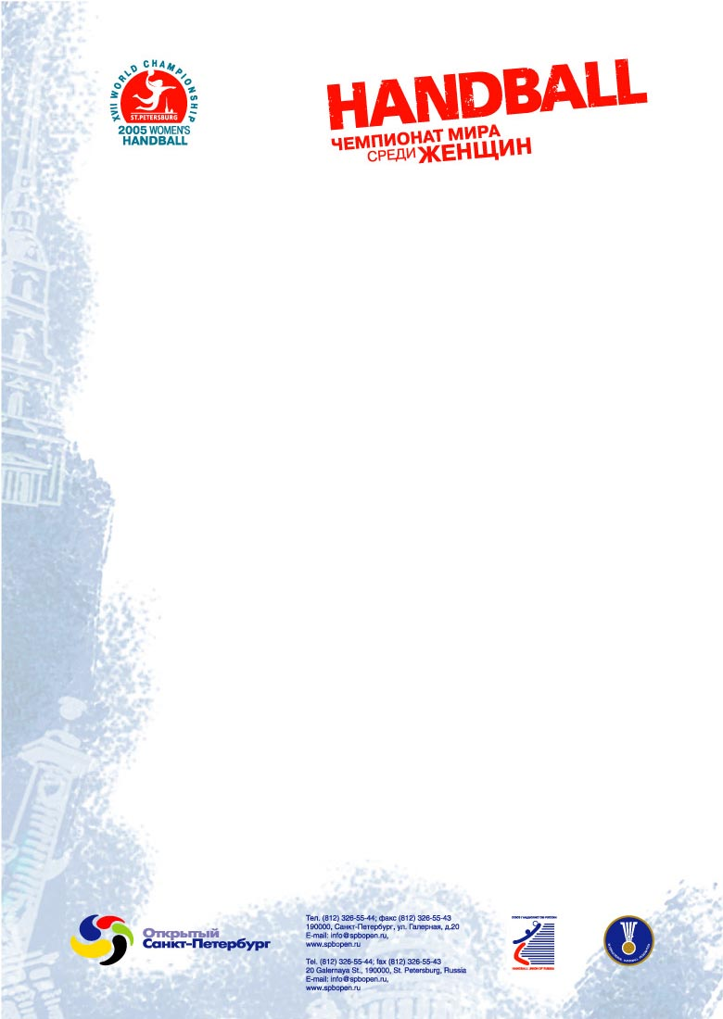

Press center activities
at
XVII Women’s world handball championship

Dear Colleagues,

The Championship press center head office at Ice (Ledovy) Palace will open 3 December 2005 at Noon.

The press center opening hours during the championship will be daily, Noon to 11:30 pm.

Press centers at Jubileyny Sports Palace and Petersburg Sports and Concert Complex will open not later than 2 hours prior the beginning of the first match of the day and close 2 hours after the last game.

Accreditation Centers:
2 – 4 December | Pribaltyskaya Hotel | 11 a.m. – 6 p.m.
5 December | Ice Palace | 11 a.m. – 8 p.m.
6 – 10 December | Ice Palace | 1 p.m. – 8 p.m.

NB At the accreditation center you have to inform the clerk about the status of your accreditation (TV official, TV non-official, press, photo)

TV and radio broadcast rights were passed by IHF to the German marketing company SportFive. In Russia the broadcast rights belong to NTV+.

TV, radio and Internet companies that didn’t buy the broadcast right can’t make live reports from the matches. Therefore their working are is limited to the mixed zones and after-match press-conferences. They also can make programs about the Championship.

In case you are interested to receive a daily newsletter from the Championship, please make sure we have your email address in our database.

Press Department
XVII Women’s World Handball Championship
+ 7 (812) 326 55 44
apetrov@spbopen.ru
www.wwhc2005.ru

